“AGENCY NAME”
Title of event: “Cook Off”
Suggested Donation Amount: $

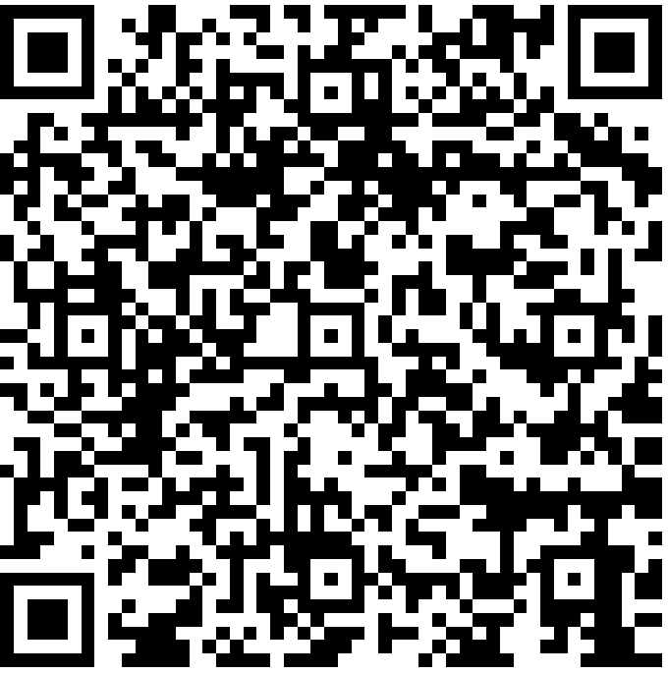

Or TEXT “givingstate” to 41444 to receive a direct link.
QR code will take you to a fundraise.givesmart.com to process your payment.
Please include “title of event” when asked for Event Description

