

“AGENCY NAME”
Title of event: “Cook Off”
Suggested Donation Amount

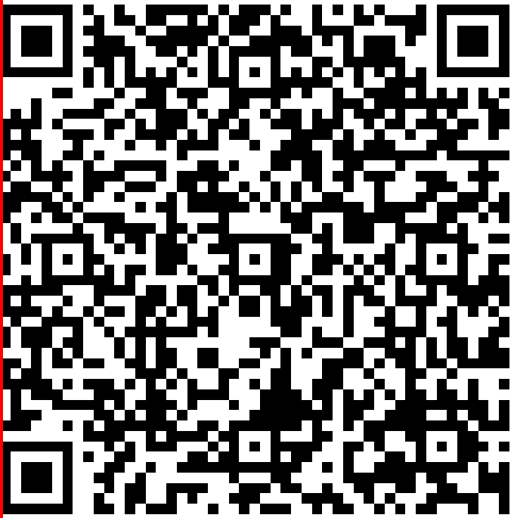

or TEXT “givinguwm” to 41444 to receive a direct link

QR code will take you to a fundraise.givesmart.com to process your payment.

